Development and Planning
Difference between Economic Growth and Economics Development
Economic growth measures an increase in Real GDP (real output). GDP is a measure of the national income / national output and national expenditure. It basically measures the total volume of goods and services produced in an economy.

Economic development looks at a wider range of statistics than just GDP per capita. Development is concerned with how people are actually affected. It looks at their actual living standards and the freedom they have to enjoy a good standard of living.
- Vicious Circle of Poverty:

Definition and Explanation:

According to Prof. Nurkse:

"It is the vicious circle of poverty (VCP) which is responsible for backwardness of UDCs".

Vicious circle of poverty:

"Implies a circular constellation of forces tending to act and react in such a way as to keep a country in the state of poverty".

In such state of affairs the process of capital formation remains obstructed and restricted. This VCP is presented as:

We start with low real income which results in a meager savings which in turn will check investment. Low level of investment would create deficiency of capital which in second round leads to low productivity. This again results in low income. Here, the circle perpetuates the low level of development.

From the supply side, there is low income, low savings, low investment, capital deficiency and low productivity.

On the demand side, low income, low demand for goods, limited home market and low investment.

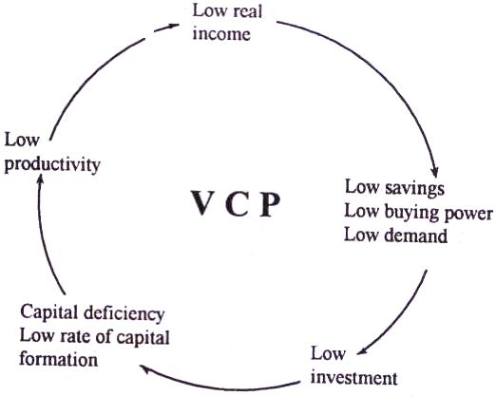

According to Nurkse, a break through on demand side can be brought about by dashing initiatives on the part of entrepreneurs. On the supply side the disguised unemployment ranging between 20% to 30% of total agri. labor force can be mobilized for financing capital formation. And the parents of such disguised unemployed will go on feeding them. It means that in Nurkse's model the hidden food surplus will finance the process of economic growth.
2.LEWIS MODEL OF ECONOMIC DEVELOPMENT WITH UNLIMITED LABOUR SUPPLY

W. Arthur Lewis has presented a theory of economic development with the use of unlimited supply of labour. The supply of labour in underdeveloped countries generally is perfectly elastic at the current wage rate. That is an unlimited supply of labour is available at the subsistence wage. This unlimited supply of labour is drawn from surplus agricultural labour casual labour, domestic servants, women in households, etc. In all these sectors, the marginal productivity of labour is negligible or zero. Lewis model is more in accord with this reality. His model is not based or disguised unemployment but on some other conditions, viz. (a) The wage rate in the industrial sector is above its marginal productivity in the subsistence sector by a small but fixed margin. (b) The investment in the industrial sector is not large relative to population growth. (c) The cost of training of the skilled workers is constant. In his model, Lewis analyses the process of economic development in terms of inter-sectoral relationships in a dual economy composed of a capitalist (manufacturing, mining, etc.). Sector and a subsistence sector of the self -employment sector. In an overpopulated country, the capitalist sector draws labour from the subsistence sector of which there is an almost unlimited supply.
Since marginal productivity in the capitalist sector is higher than the current wage rate, it yields a surplus or profits to the capitalist. The surplus is reinvested and creates new capital, which in turn raises the marginal productivity and increases employment in the capitalist sector. This process does not raise wages but increases the surplus or share of profits in the national income. This process goes on profits grow relatively as the capitalist sector expands and capital formation increases.

Diagrammatically
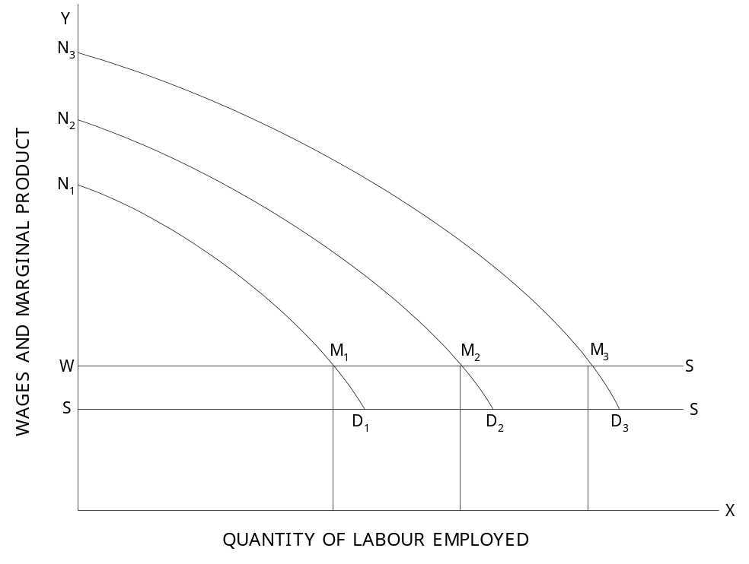

In this diagram, quantity of labour is represented along OX and wages and marginal productivity
along OY. OS represents subsistence earnings and OW capitalist wage. WS is the perfectly elastic supply of labour at OW the capitalist wage. Initially the demand for labour is represented by the marginal productivity curve of labour, N₁ D₁. Labour is employed up to the point where the marginal productivity equals the current wage rate OW. Thus the amount of labour employed initially is OL₁, Labour share (i.e. wages) in the total product ON₁. M₁L₁ is OW M₁L₁ and share of profits or surplus going to the capitalist is WN₁M₁. On reinvestment of the profits, the marginal productivity of labour rises to N₂D₂, and employment of labour will increase to OL₂. In the same way, farther investment will raise the marginal productivity of labour to N₃D₃ and employment increases further to OL₃ and capitalist’s surplus on profits to WN₃M₃.This process repeats itself.

Arthur Lewis, however points out that the process of economic growth must come to an end (a) when no surplus labour is left (b) When population declines (c) when food prices rise pushing up wages and (d) when workers press for higher wages.

Planning

Economic planning is a resource allocation system in which the government makes economic decisions based on an economic plan. Planning is a mechanism for the allocation of resources between and within organizations contrasted with the market mechanism. As an allocation mechanism for socialism, economic planning replaces factor markets with a procedure for direct allocations of resources within an interconnected group of socially owned organizations which comprise the productive apparatus of the economy.

Conditions Necessary for the Success of Economic Planning
1. Central-Planning Authority:
The most significant conditions for the success of planning is the setting of central planning authority.
For instance, in India, there is Planning Commission and in Russia, there is Gosplan. This body carries a group of experts, economists, statisticians, engineers etc. who deal with the different aspects of the economy. They suggest measures for the proper implementation of the plan.
2. Reliable Statistical Data:
A pre-requisite for the sound and successful planning is the availability of reliable, adequate and accurate statistical data relating to various fields of the economy. For obtaining necessary statistical information, a survey of the existing and potential resources has to be undertaken like raw-material, capital, human and natural resources of the country.
3. Specific Objective:
Another imperative condition for the success of economic planning is the specific objective. The prescribed objectives should be definite and laid down in an order of priority keeping in view the urgency of economy’s problems. Moreover, objectives should not be too many in number but should be realistic, mutually compatible, flexible and feasible within means.
4. Fixation of Targets and Priorities:
It is equally necessary to fix the targets and priorities and further capability of their achievement. In other words, those schemes or projects which are required to be executed first, should be given top priority and less significant projects should have low priority. The programmes of priorities should not be much rigid: rather it may be changed according to the requirements of the economy. These targets should be mutually consistent for attaining a particular growth rate for the economy.
5. Suitable Economic Organisation:
For the success of planning there must be suitable economic organisation which promotes but do not hinder the progress of the country. In other words, socialistic economic organisation in which means of production are socialized is a basic condition for the realistic planning in a country. But on the contrary, the experience of capitalistic countries show that private enterprise never promotes planning.
6. Strong and Stable Government:
The success of economic planning also depends on the strong and stable government with a high degree of authority. Planning process is in danger in many underdeveloped countries due to frequent change in their governments. In this matter, India is fortunate enough as it enjoyed considerate political stability during the period of its planning process.
7. Fair and Efficient Administration:
The administrative machinery with a high degree of honesty and efficiency plays very pioneer role in the formulation and implementation of plans. Our country has a bitter experience in this regard. Even the best plans fail due to corrupt, inefficient, inactive and lethargic administration.
8. Mobilization of Resources:
The success of planning, in fact, is based on the proper mobilization of financial resources of the country. In an underdeveloped country, resources are inadequate and irregular, ineffectively developed and mobilized to the required extent.

